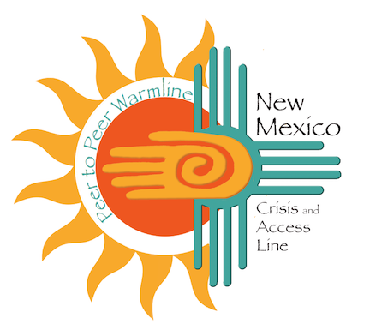

What is the New Mexico Peer-to-Peer (P2P) Warmline?

- A phone number anyone can call to talk to someone who has “been through it”.

- Peer Support Specialists are employed by NMCAL/ProtoCall to provide non-crisis telephonic support to individuals who are seeking support and resources as a result of a behavioral health need.

- Staffed entirely by people with lived experiences, that have completed the state certified Office of Peer Recovery and Engagement Peer program

- Engages the person before they are in a crisis.

- Can reduce psychiatric hospitalizations.

- Increases the use of more natural community and self-help supports.

Why is the New Mexico P2P important?
- The New Mexico P2P is well aligned with the movement towards recover and resiliency services and the inclusion of Peer Support Specialist as a unique discipline within the behavioral health workforce.

- Through the promotion of recovery services, individuals identifying as having a behavioral health diagnosis can move away from an illness-focused perspective towards one focused on hope, long-term goal setting, strength-based and wellness.

- In the process, individuals develop “recovery capital” including support systems, personal and professional, and the development of community-based supports that aid in long-term recovery.

- Individuals in recovery-based services are often supported by Peer Support Specialists who are trained through a specialized curriculum to serve as navigators through the system of care and use their own lived experience to help individuals develop long-term community-based supports and person-centered tools.

- The inclusion of a Warmline within the New Mexico system of care serves as a potential diversion from higher, more intrusive and disruptive levels of care, and instead offers more inclusive and iterative levels of care, and individuals with greater choice in the pursuit of their recovery goals.

Why call the Warmline?
- Just need to someone to talk to

- Need to talk to someone that has been there and has lived experience with some of the same things the caller may be going through

- Seeking support for yourself, or someone else, struggling with mental, behavioral, emotional, social health and well-being.

- Struggling with drugs and/or alcohol, feeling lonely, isolated, and/or withdrawn,

- Looking for services in your area to help you with your next step in recovery and resiliency.

How do you reach a Peer?
1-855-4NM-7100 (1-855-466-7100)

When is a Peer available?
- A Peer Support Specialist is available for anyone to call 24 hours a day, 7 days a week, 365 days a year.

- Peer Support Specialists are staffed and available to support callers from 3:30 pm – 11:30 pm MT every day.

- If a call for the New Mexico Warmline is made outside of the times when peer specialists are staffed, or if a peer specialist is not available to talk to, the caller has an option to talk to a crisis line counselor by pressing 1.

- If a Warmline caller speaks to a clinician, they will receive the same support all other crisis line callers receive.

Background
The New Mexico P2P Warmline is inspired by the 2011 recommendations of the HJM 17 Task Force, which identified the vision of a Statewide Warmline.

“Local Collaboratives that have warm lines in their communities report that they are highly effective, but they are not widely or consistently available throughout the sates. This is the case even though they are an economical and effective resource to prevent crisis and improve client quality of life.”

HJM17 specifically envisioned a statewide warmline well integrated into the operations of a Statewide Crisis Line,

